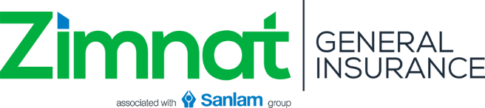
MARINE CARGO INSURANCE PROPOSAL FORM
Important Note: Take care to complete this form fully and correctly. Failure to disclose a material fact (any fact likely to influence the company’s acceptance and assessment of this proposal) will render the insurance void. If you are in doubt of the facts which might be considered material, you should disclose them. The liability of the company does not commence until Zimnat Lion has accepted this proposal and the premium paid.

GENERAL INFORMATION OF THE PROPOSER
SURNAME (Mr/Mrs/Ms/Mrs/Dr) |  | FORENAME(S)
Name of Organization
Postal Address |  |  |  |  | E-Mail Address
Residential/Business Address
Occupation |  |  | Date Of Birth
Phone Number |  |  |  | Mobile Phone Number

RISK DETAILS
Nature of goods to be transported
Mode of conveyance |  |  |  |  | Method of packaging
Limit any one conveyance |  |  |  |  | Estimated Annual Carry
Voyage | From: |  |  |  | To:
Cover required (tick applicable) |  |  |  All risks Fire, collision and overturning | Basis of valuation

TRANSPORTING VEHICLE DETAILS
Make | Model | Registration Number | Tonnage

LOSS HISTORY
Annual Turnover for past 3 years
Previous Insurer
Losses suffered in the past 3 years | Year | Brief Nature of loss | Total Amount Claimed
I/we agree that this proposal shall be the basis of the contract between me/us and Zimnat Lion Insurance Company. I/we declare that the statements made in this proposal are true and correct to the best of my/our knowledge and belief and I/we agree to accept and abide by the Zimnat Lion Insurance Company’s form of policy for the risks now proposed.

Name of representative  (If Company) |  | Designation |  | Signature |  | Date

